Title of the Master Thesis
Subtitle

Master Thesis

Submitted: December 20, 2022

By: Max Mustermann
born on March 23, 1990
in Mannheim, Germany
Matriculation number: 0123456
Course of Study:

Supervisor: Jun.-Prof. Dr. Jana-Rebecca Rehse

University of Mannheim
Junior Professorship of Management Analytics
L15 1-6, 68161 Mannheim
Homepage: https://www.bwl.uni-mannheim.de/rehse/

Table of Contents

List of Figures iii
List of Tables iv
List of Abbreviations v
Abstract 1
1 Introduction 2
2 Foundations 3
3 Methodology 4
4 Results 5
5 Conclusions 6
5.1 Summary of findings 6
5.2 Limitations 6
5.3 Recommendations for future research 6
Bibliography i
Appendix ii
Affidavit iii

List of Figures
Figure 1: Analysis of identified Papers 3

List of Tables
Table 1 Sample table 6
Table 2 Items Used to Measure Each Construct ii

List of Abbreviations
BI Business Intelligence
BPI Business Process Intelligence
BPM Business Process Management
DW Data Warehouse
PM Process Mining

Abstract
Abstract text is here.
PLEASE NOTE:
Your thesis should follow MIS Quarterly instructions for full-length research articles: https://misq.org/categories
Document length: ca. 60 pages content (content pages are using Arabic numbers as page number format, while other non-content pages are following roman page numbers). Content includes text, tables, and figures.
MISQ References and Citations Format: References should be listed alphabetically by author name in conformance with APA 7th edition. In-text citations should be indicated by the author’s last name and year of publication, e.g., (DeGross, 1977) or DeGross (1977).
Make sure to have the right settings. E.g. with Mendeley plugin:
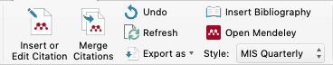
The output should look like this:
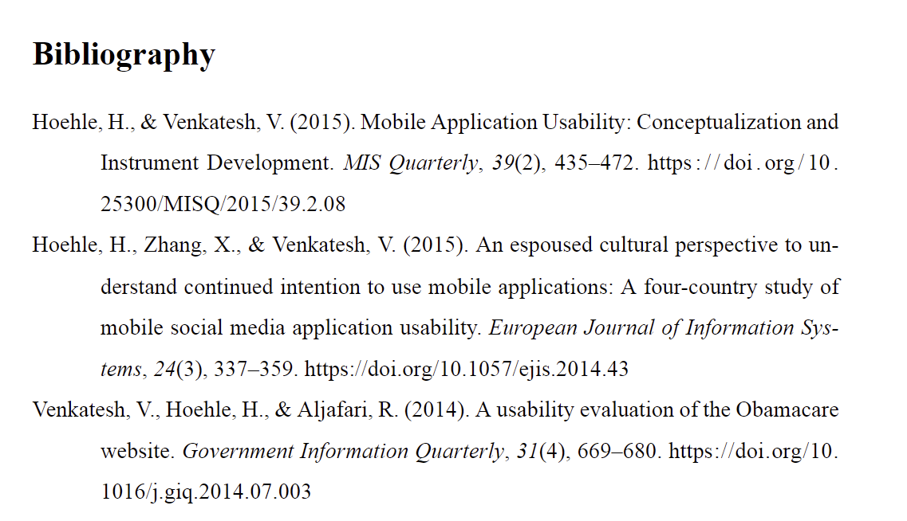
Remove this note in your final version!

Introduction
The role of information systems in modern business solutions is indisputable, [...] Developing such a solution is the goal of this work (Venkatesh et al., 2014).

Foundations
Process mining needs to access [...] and used by many large-scale companies (Hoehle & Venkatesh, 2015) across the world.
2.1 A sub-section
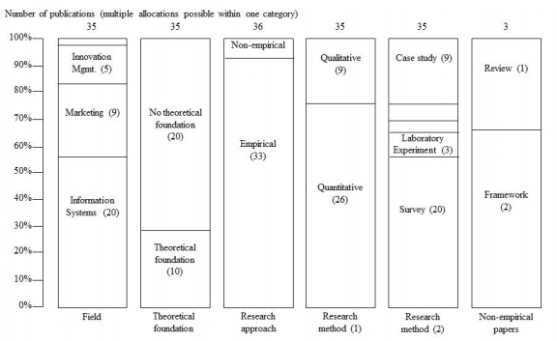
Figure 1: Analysis of identified Papers
The work of Hoehle et al. (2015) provides a solution for this problem in terms of
[..].
2.2 Yet another sub-section
As you can see in the figure 1, everything looks better in a diagram. Also, in the
page 2 is the same example.

Methodology
A solution for the aforementioned problem can be achieved by developing a software [...] would be able to start process mining tasks using this event log (Hoehle et al., 2015; Venkatesh et al., 2014).

Results
Currently only few tools are focusing [...] The findings in this area will be covered and be used to draw the essential requirements of the final solution.

Citation examples
And here we demonstrate like (Hoehle et al., 2015) how citations look alike. You can also have multiple citations (Hoehle et al., 2015; Venkatesh et al., 2014). Or cite in the text like this: Hoehle and Venkatesh (2015).

Conclusions
Giving the conclusion here.

Summary of findings
Here is a sample table.
Survey | Construct | Item Used | Source
Job  (Survey 1) | ***
 | ***
General  (survey 2) | ***
Table 1 Sample table

Limitations

Recommendations for future research

Bibliography
Hoehle, H., & Venkatesh, V. (2015). Mobile Application Usability: Conceptualization and Instrument Development. MIS Quarterly, 39(2), 435–472. https://doi.org/10.25300/misq/2015/39.2.08
Hoehle, H., Zhang, X., & Venkatesh, V. (2015). An espoused cultural perspective to understand continued intention to use mobile applications: a four-country study of mobile social media application usability. European Journal of Information Systems, 24(3), 337–359. https://doi.org/10.1057/ejis.2014.43
Venkatesh, V., Hoehle, H., & Aljafari, R. (2014). A usability evaluation of the Obamacare website. Government Information Quarterly, 31(4), 669–680. https://doi.org/10.1016/j.giq.2014.07.003

Appendix
All tables, results, interview data, collected data, used in the report, could be presented here.

Survey | Construct | Item Used | Source
Job  (Survey 1) | ***
 | ***
General  (survey 2) | ***
 | ***
 | ***
Table 2 Items Used to Measure Each Construct

Affidavit
I hereby declare that I have developed and written the enclosed master thesis entirely on my own and have not used outside sources without declaration in the text. Any concepts or quotations applicable to these sources are clearly attributed to them. This master thesis has not been submitted in the same or a substantially similar version, not even in part, to any other authority for grading and has not been published elsewhere. This is to certify that the printed version is equivalent to the submitted electronic one. I am aware of the fact that a misstatement may have serious legal consequences.
I also agree that my thesis can be sent and stored anonymously for plagiarism purposes. I know that my thesis may not be corrected if the declaration is not issued.

Mannheim, December 20, 2022

Max Mustermann

