Chair of Service Operations Management
Prof. Dr. Cornelia Schön
Supervisor: Titel prename surname

Master-Thesis

Title

Candidate in the ”XXX“ program
Prename surname
University E-Mail XXXXXXXXX
Matr. No. XXXXXXXXX

Place, handover date

Abstract

Lorem ipsum dolor sit amet, consectetuer adipiscing elit. Maecenas porttitor congue massa. Fusce posuere, magna sed pulvinar ultricies, purus lectus malesuada libero, sit amet commodo magna eros quis urna. Nunc viverra imperdiet enim. Fusce est. Vivamus a tellus.
Pellentesque habitant morbi tristique senectus et netus et malesuada fames ac turpis egestas. Proin pharetra nonummy pede. Mauris et orci. Aenean nec lorem. In porttitor. Donec laoreet nonummy augue. Suspendisse dui purus, scelerisque at, vulputate vitae, pretium mattis, nunc. Mauris eget neque at sem venenatis eleifend. Ut nonummy. Fusce aliquet pede non pede. Suspendisse dapibus lorem pellentesque magna. Integer nulla.
Donec blandit feugiat ligula. Donec hendrerit, felis et imperdiet euismod, purus ipsum pretium metus, in lacinia nulla nisl eget sapien. Donec ut est in lectus consequat consequat.
Etiam eget dui. Aliquam erat volutpat. Sed at lorem in nunc porta tristique.

Table of Contents
List of Figures IV
List of Tables V
List of Abreviations VI
List of Symbols VII
1 Introduction 1
1.1 Problem definition and motivation 1
1.2 Thesis structure 1
2 Fundamentals 1
2.1 Basic terms 1
2.1.1 A1 1
2.1.1.1 A11 1
2.1.1.2 A12 1
2.1.1.3 A13 1
2.1.2 A2 1
2.2 Approaches in the literature 1
3 A model for optimal pricing 1
3.1 Model assumptions 1
3.2 Data basis 1
3.2.1 B1 2
3.2.2 B2 3
3.3 Optimisation model 3
3.4 Structure analysis 3
3.5 Solution procedure and aspects of implementation 3
3.6 Model evaluation 3
4 Case Study 3
5 Discussion of results 3
6 Conclusion and future outlook 3
Appendix A: Sozio-demography of praticipants VIII
Appendix B: Source code VIII
List of References IX

List of Figures

Figure 1: Procedure of FMR 2

List of Tables

Table 1: Indices and variables in the modell of FMR 2

List of Abreviations

Examples:

C/D Confirmation/Disconfirmation
EM Expectation-Maximization
FM Finite Mixture
FMR Finite Mixture Regression

List of Symbols (Optional)

Examples:
σ standard deviation
μ mean
C correlation matrix

1 Introduction

Problem definition and motivation
Lorem ipsum dolor sit amet, consectetuer adipiscing elit. Maecenas porttitor congue massa. Fusce posuere, magna sed pulvinar ultricies, purus lectus malesuada libero, sit amet commodo magna eros quis urna. Nunc viverra imperdiet enim. Fusce est. Vivamus a tellus.
Pellentesque habitant morbi tristique senectus et netus et malesuada fames ac turpis egestas. Proin pharetra nonummy pede. Mauris et orci. Aenean nec lorem. In porttitor. Donec laoreet nonummy augue. Suspendisse dui purus, scelerisque at, vulputate vitae, pretium mattis, nunc. Mauris eget neque at sem venenatis eleifend. Ut nonummy. Fusce aliquet pede non pede. Suspendisse dapibus lorem pellentesque magna. Integer nulla.
Donec blandit feugiat ligula. Donec hendrerit, felis et imperdiet euismod, purus ipsum pretium metus, in lacinia nulla nisl eget sapien. Donec ut est in lectus consequat consequat.
Etiam eget dui. Aliquam erat volutpat. Sed at lorem in nunc porta tristique. Proin nec augue. Quisque aliquam tempor magna. Pellentesque habitant morbi tristique senectus et netus et malesuada fames ac turpis egestas. Nunc ac magna. Maecenas odio dolor, vulputate vel, auctor ac, accumsan id, felis. Pellentesque cursus sagittis felis.
Pellentesque porttitor, velit lacinia egestas auctor, diam eros tempus arcu, nec vulputate augue magna vel risus. Cras non magna vel ante adipiscing rhoncus. Vivamus a mi. Morbi neque. Aliquam erat volutpat. Integer ultrices lobortis eros. Pellentesque habitant morbi tristique senectus et netus et malesuada fames ac turpis egestas. Proin semper, ante vitae sollicitudin posuere, metus quam iaculis nibh, vitae scelerisque nunc massa eget pede. Sed velit urna, interdum vel, ultricies vel, faucibus at, quam. Donec elit est, consectetuer eget, consequat quis, tempus quis, wisi. In in nunc. Class aptent taciti sociosqu ad litora torquent per conubia nostra, per inceptos hymenaeos. Donec ullamcorper fringilla eros. Fusce in sapien eu purus dapibus commodo. Cum sociis natoque penatibus et magnis dis parturient montes, nascetur ridiculus mus. Cras faucibus condimentum odio. Sed ac ligula. Aliquam at eros.
Etiam at ligula et tellus ullamcorper ultrices. In fermentum, lorem non cursus porttitor, diam urna accumsan lacus, sed interdum wisi nibh nec nisl. Ut tincidunt volutpat urna. Mauris eleifend nulla eget mauris. Sed cursus quam id felis. Curabitur posuere quam vel nibh.

Ambition of the thesis

Thesis structure

Fundamentals

Basic terms

A1

A11

A12

A13

A2

Approaches in the literature

A model for optimal pricing

Model assumptions

Data basis

B1

Spezifizierung des Modells / Überprüfung der Datenbasis
Parameterschätzung (Softwareeinsatz)
Newton-Raphson
EM-Algorithmus
Bestimmung der Anzahl an Segmenten
Informationskriterien
Klassifikationsfehler
Stabilität
Interpretierbarkeit
Interpretation der Segmente (ergebnisabhängig)
Koeffizienten
Demographika

Figure 1: Procedure of FMR (self-provided)

B2
Indices and variables used within FMR are listed below in table 1.

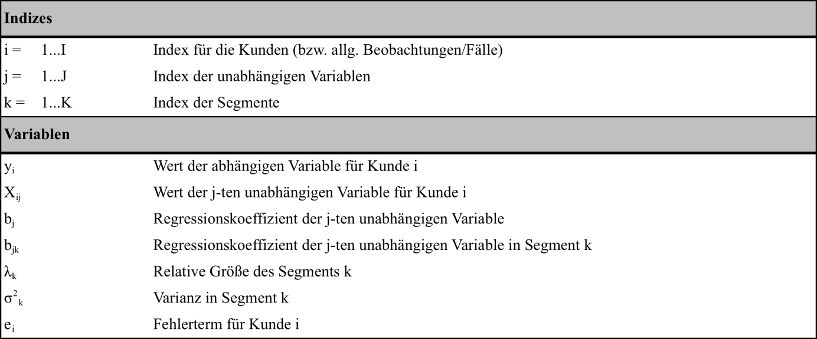
Table 1: Indices and variables in the modell of FMR
Source: Following DeSarbo/Cron (1988, p. 250ff.)

Optimisation model

${\left(x+a\right)}^{n}=\sum_{k=0}^{n}{\left({n \atop k}\right)x^{k}a^{n-k}}$ (3.1)

Structure analysis

Solution procedure and aspects of implementation

Model evaluation

Case Study

Discussion of results

Conclusion and future outlook

Appendix A: Sozio-demography of praticipants
…

Appendix B: Source code
…

List of References

Caimi, G. (2009): Algorithmic decision support for train scheduling in a large and highly
utilized railway network. Dissertation, ETH Zürich. // dissertation & habilitation
Helber, S., K. Schimmelpfeng, and R. Stolletz (2011): Setting inventory levels of CONWIP
lines via linear programming. Business Research 4 (1), 98-115. // article
Irnich, S., and G. Desaulniers (2005): Shortest Path Problems with Resource Constraints,
in: Desaulniers, G., J. Desrosiers, and M. M. Solomon (Eds.): Column Generation. Springer, Berlin, 33-36. // collected edition
Jalil, M.N., R.A. Zuidwijk, M. Fleischmann, and J.A.E.E. van Nunen (2011): Spare parts
logistics and installed base information. Journal of the Operational Research Society 62
(3), 442-457. // article
Nickel, S., O. Stein, and K.-H. Waldmann (2014): Operations Research (2nd edition).
Springer, Berlin. // monography
Sampson, S. E. (2012): Essentials of Service Design. Assessed June 07, 2014, [available at
services.byu.edu]. //online-source

Eidesstaatliche Erklärung (Affidavit)
Hiermit versichere ich, dass diese Abschlussarbeit von mir persönlich verfasst ist und dass ich keinerlei fremde Hilfe in Anspruch genommen habe. Ebenso versichere ich, dass diese Arbeit oder Teile daraus weder von mir selbst noch von anderen als Leistungsnachweise andernorts eingereicht wurden. Wörtliche oder sinngemäße Übernahmen aus anderen Schriften und Veröffentlichungen in gedruckter oder elektronischer Form sind gekennzeichnet. Sämtliche Sekundärliteratur und sonstige Quellen sind nachgewiesen und in der Bibliographie aufgeführt. Das Gleiche gilt für graphische Darstellungen und Bilder sowie für alle Internet-Quellen.
Ich bin ferner damit einverstanden, dass meine Arbeit zum Zwecke eines Plagiatsabgleichs in elektronischer Form anonymisiert versendet und gespeichert werden kann.

Place, Date

SIGNATURE

Prename lastname

Affidavit (translated version for information, not legally binding)
I hereby declare that the paper presented is my own work and that I have not called upon the help of a third party. In addition, I affirm that neither I nor anybody else has submitted this paper or parts of it to obtain credits elsewhere before. I have clearly marked and acknowledged all quotations or references that have been taken from the works of others. All secondary literature and other sources are marked and listed in the bibliography. The same applies to all charts, diagrams and illustrations as well as to all Internet resources.
Moreover, I consent to my paper being electronically stored and sent anonymously in order to be checked for plagiarism. I am aware that the paper cannot be evaluated and may be graded "failed" ("nicht ausreichend") if the declaration is not made.

